the esp32 pcb is almostly like the clockwise project.
but you can not use the bin in the github.
you need use vscode download the flash by this source.

after download the flash.you need connet the wifi for the esp32pcb.
if it is displaying wifi failed.you need connect the wifi by usb-to-ttl cable.
and use the website to download the wifi informations.
The website is https://clockwise.page.
You need connet the esp32 pcb with the website and click the CONNECT!.

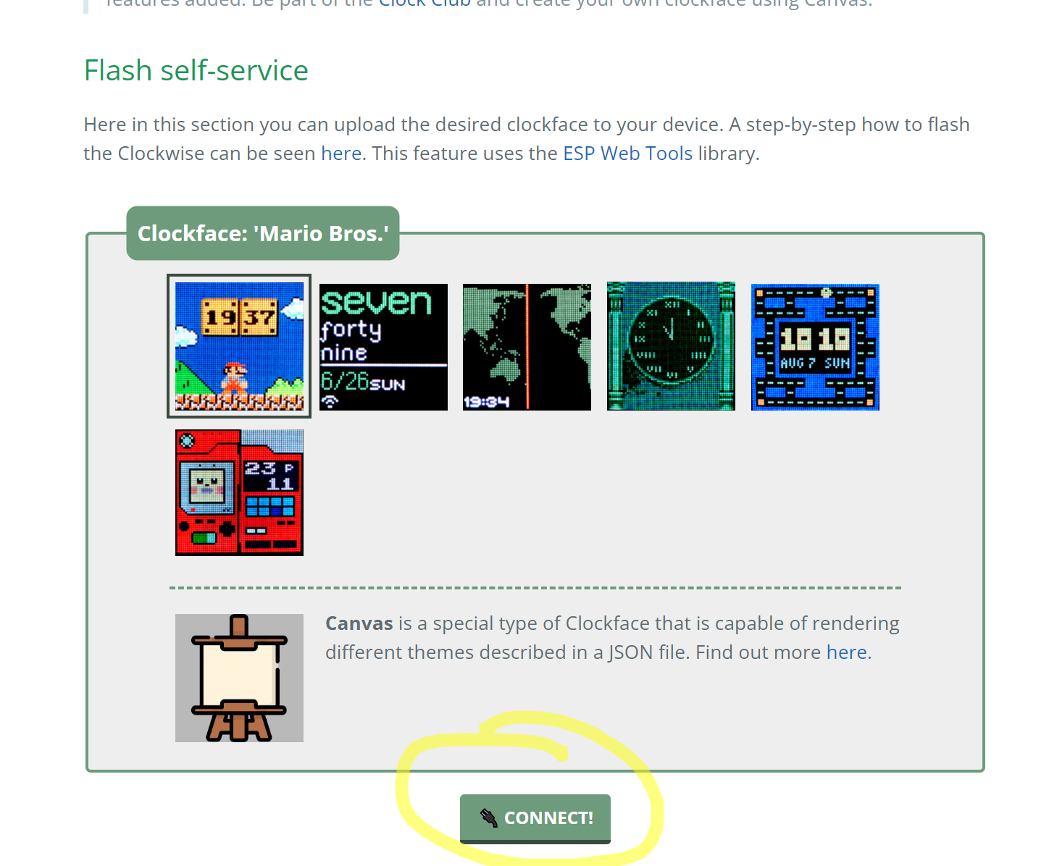
If the clock display “wifi ...ap”,then it is in ap mode.
You need use the phone or computer search the wifi singal that named”clockwise”
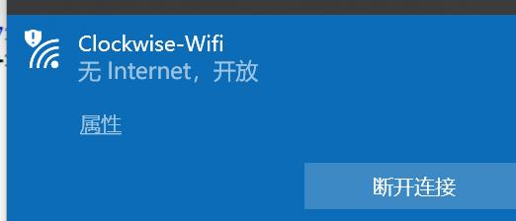
And then connect it.
Input the website to the browser “192.168.4.1”.
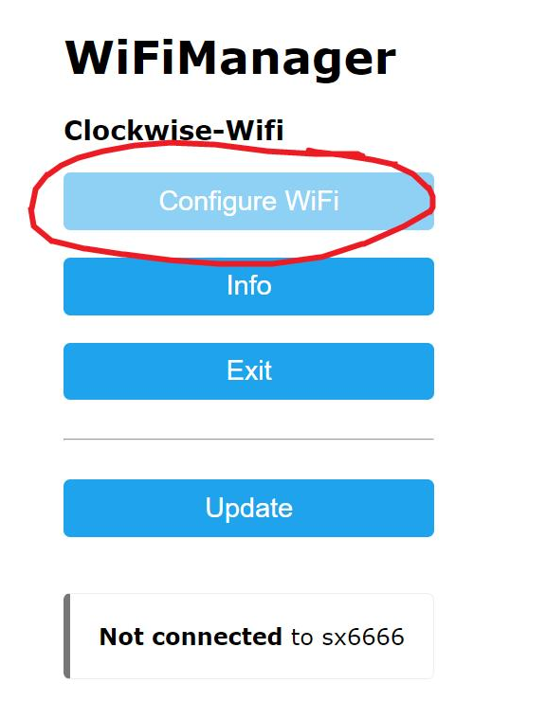
Click configure WiFi.
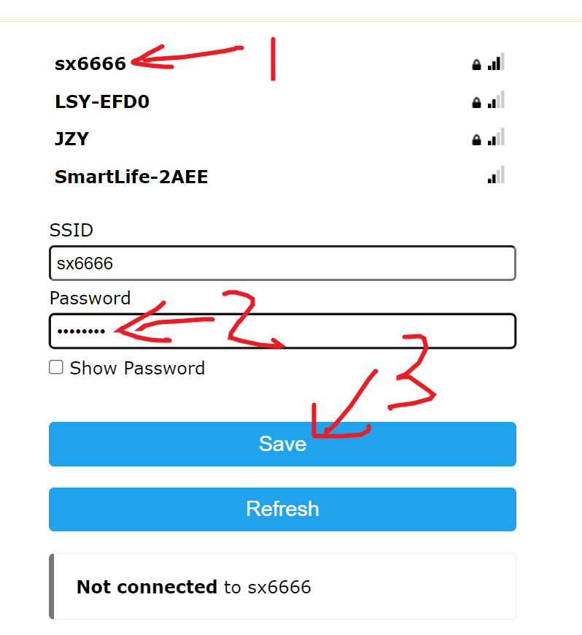
Lastly if you connceted the esp32 to the wifi.you may open the router website and find the ip address of esp32.then input the ip address
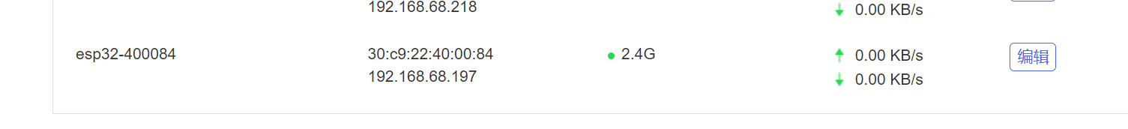
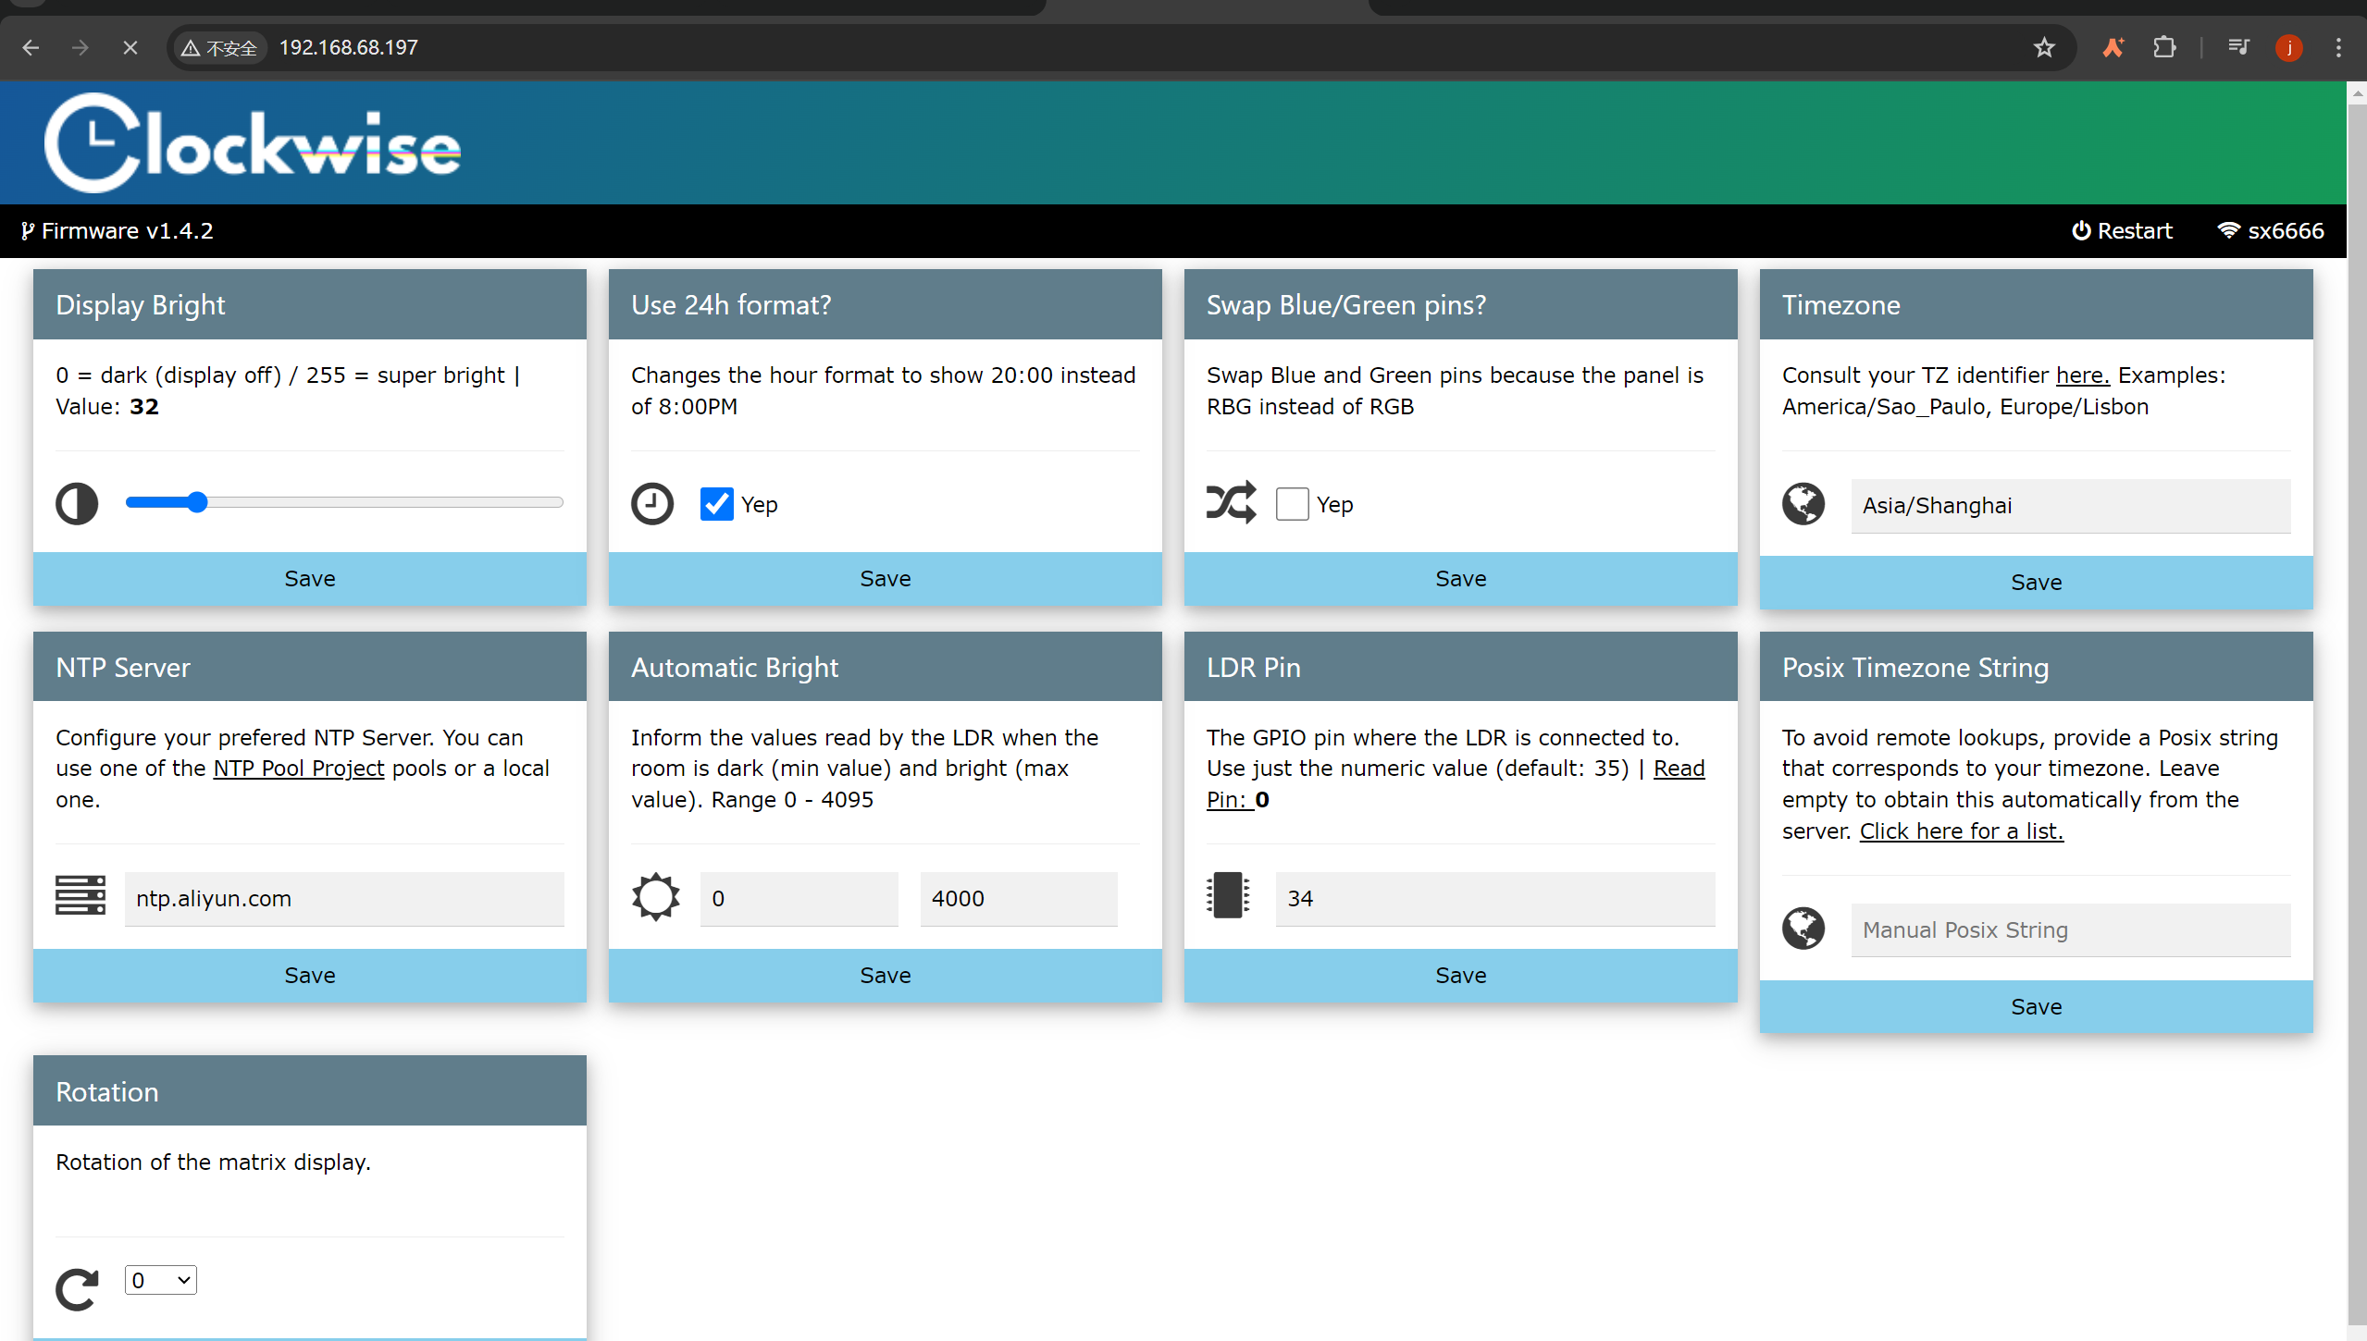

How to download the flash
- power the esp32pcb with TYPE-C calbe。
- Connect the Download pin with a usb-TO-ttl cable to the computer
- Keep pressing IO0 and short press RST key，then release the RST key，after that release the IO0 key。
